UNIT-2
- Multi-layer Perceptron
- Going Forwards
- Going Backwards: Back Propagation Error
  - The Multi-layer Perceptron Algorithm
  - Initializing the Weights
  - Different Output Activation Functions
  - Sequential and Batch Training
  - Local Minima
  - Picking up Momentum
  - Minibatch and Stochastic Gradient Descent
- Multi-layer Perceptron in Practice
  - Amount of Training Data
  - Number of Hidden Layers
  - When to Stop Learning
- Examples of using the MLP
  - A Regression Problem
  - Classification with the MLP
  - A Classification Example: The Iris Dataset
  - Time-Series Prediction
  - Data Compression: The Auto-Associative Network
- Overview (List and explain the features of using MLP within a dataset)
- Overview – Deriving Back-Propagation
- Radial Basis Functions and Splines – Concepts –RBF Network
- Curse of Dimensionality
- Interpolations and Basis Functions
- Support Vector Machines

Multi-layer Perceptron
A Perceptron is a type of artificial neural network and a binary linear classifier. It takes multiple input features, multiplies each by a weight, adds a bias, and passes the result through an activation function (usually a step function) to produce an output (0 or 1).Multi-layer Perceptron is one type of Perceptron.
A Multilayer Perceptron (MLP) is a type of artificial neural network (ANN) that can be used to solve regression problems, binary classification problems, and multi-class classification problems.
Classification means Predicts discrete categories (e.g., spam vs. not spam)
Regression means Predicts continuous values (e.g., house prices).
MLPs are parametric models because they have a fixed number of parameters (weights and biases) that are learned from data

Key Components of MLP
- Input Layer: Receives the input features.
- Hidden Layers: An MLP can have any number of hidden layers, with each layer containing any number of nodes. These layers process the information received from the input layer.
- Output Layer: The output layer generates the final prediction or result.
The activation functions used in the layers can be linear or non-linear depending on the type of the problem modeled.
In a MLP, learning happens by changing the weights. The back-propagation algorithm helps the network adjust these weights to reduce the difference between its predicted and actual outputs.
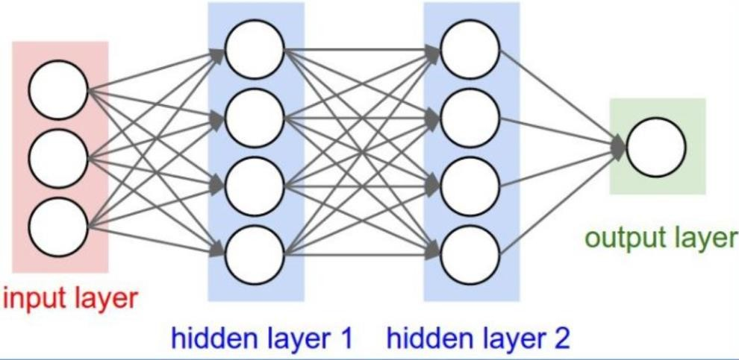

Regression problems: The output layer usually has one neuron with a linear activation function, so the MLP can predict continuous values like house prices or temperature.

Binary classification problems: The output layer usually has one neuron with a sigmoid activation function that outputs a value between 0 and 1, representing the probability of one of two classes

Multi-class classification problems: The output layer has multiple neurons with a softmax activation function, where each neuron represents a class, and the class with the highest probability is chosen as the prediction.

Because of its layered structure and ability to learn non-linear patterns, an MLP is a powerful and flexible model for both classification and regression tasks.

Task Type | Output Layer Setup | Activation Function | Example
Regression | One neuron | Linear (or no  activation) | House price  prediction
Binary Classification | One neuron | Sigmoid | Spam vs Not Spam
Multi-class Classification | Multiple neurons (one per  class) | Softmax | Digit recognition  (0–9)

Going Forwards
A MLP is trained using two main steps:
- Forward propagation: - Calculate the output based on the given inputs and current weights.
- Back propagation:- Adjust the weights based on the error (the difference between the actual output and the expected target).
Going forwards is also called as Forward propagation Going backwards is also called as Back propagation
An MLP can have more than two layers—it could have 3, 4, or even 20 layers. However, adding layers doesn’t change the basic forward propagation process. We simply calculate activations for each layer and use them as inputs for the next layer.
For example:

- Input values are given: Data (features) are fed into the network.

- Hidden layer computation: Inputs are multiplied with the first set of weights, added with bias, and passed through an activation function to produce hidden layer outputs.

- Output layer computation: Hidden layer outputs are multiplied with another set of weights
to compute the final output.

- Error calculation: The predicted output is compared with the actual (target) output, and the
error is calculated.

- Backpropagation: This error is used to adjust the weights, so the model performs better next time.

This process helps the MLP learn from mistakes and improve its predictions over time.

Biases
Every neuron in the network needs a bias to improve learning.
  - We add a bias input to each neuron.
  - The bias is a special input with a fixed value of −1.
  - During training, the network adjusts the weights of the bias along with the other weights.
  - Each neuron in the hidden and output layers has this extra input.
  - The bias helps the neuron activate even when other inputs are zero

GOING BACKWARDS: Back Propagation Error
Going backwards is also called back propagation. Back propagation means adjusting the weights based on the error (the difference between the actual output and the expected target) to improve learning.

Back Propagation Error
Back propagation is a technique used to train Multi-Layer Perceptron (MLP) networks, where errors are propagated backward through the network.
While identifying errors at the output layer is easy, determining how to adjust the weights based on these errors is more complex.
Mathematical methods are the clearest way to explain back propagation, but they can be difficult to understand.
In backpropagation, x represents the input to a neuron

To train the network, we calculate an error. A common error function is:

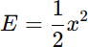

The derivative of this error function is:

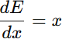

Backpropagation uses the chain rule:

Using the chain rule, the error is sent backward through the network to see how each weight causes the error. Then, the weights are adjusted to reduce the error.
The weights of the MLP are adjusted in order to reduce the error function
Ek= yk-tk
Where yk represents the predicted output and tk represents the actual output.
This method works well for a single layer, but becomes harder with multiple layers in an MLP. In MLPs, we must find which weights caused the error, including the weights from the input to hidden layer and from the hidden to output layer.

Single layer means only one set of weights between input and output, with no hidden layers.
Multiple layers means the network has more than one set of weights, usually with one or more hidden layers between input and output.

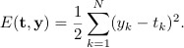
To avoid errors canceling each other out and making it look like no error happened. The following sum-of-squares error function is used

The gradient shows the direction in which the error function changes the most. Taking the derivative of the error function gives this gradient.

The gradient shows the direction in which the error increases the most. To make the error smaller, we go in the opposite direction of the gradient.

Gradient descent works like a ball rolling down a hill to reach the lowest point. In a neural network, this means the weights are changed step by step in the opposite direction of the gradient so that the error becomes smaller.
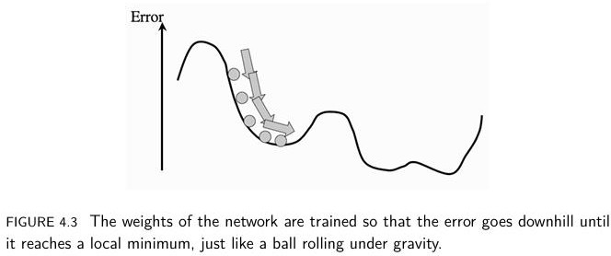

Traditional threshold functions are not smooth, so their derivatives cannot be calculated at some points. To solve this problem, smooth and differentiable activation functions are used, which allow learning using gradient-based methods.
The sigmoid function is commonly used because it has a smooth S-shaped curve and its derivative is easy to compute, which is necessary for gradient-based learning

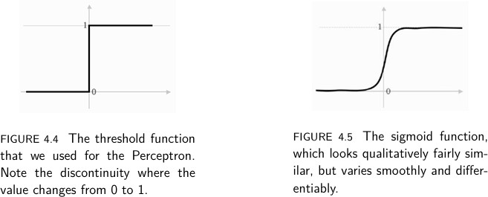

The logistic (sigmoid) and hyperbolic tangent functions (tanh) are commonly used activation functions in neural networks because they are continuous and differentiable.
Backpropagation relies on gradients, which are computed using the derivatives of these activation functions.
The sigmoid function outputs values between 0 and 1, while tanh outputs values between −1 and 1.
The logistic function:
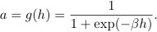
Here β is positive parameter
The hyperbolic tangent function:
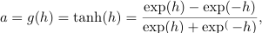

By using a better error calculation method and smooth activation functions, the network can update its weights to reduce error. The process includes:

- Passing inputs through the network.
- Detecting activated nodes.
- Calculating errors as the sum of squared differences.
- Updating the weights using the error gradient..

Backpropagation works for networks with many hidden layers. It uses the chain rule to find how error changes with weights, and then updates the weights backward to reduce the error.

The Multi-layer Perceptron Algorithm

Structure of the Network:
- The network consists of L input nodes, M hidden nodes, and N output nodes.
- In addition, there is a bias node for both the input and hidden layers, which helps improve learning.
- The number of weights connecting the layers is:
  - Between the input and hidden layer: (L+1) × M
  - Between the hidden and output layer: (M+1) × N
  - The bias input is set to -1, and the bias in the hidden layer is also set to -1.
- The network can have multiple hidden layers, with each layer having its own set of weights.

How the MLP Algorithm Works:
Input Data – Input values are applied to the input layer along with a bias.

Forward Propagation (Passing Data Through the Network):

  - The inputs are passed through the first layer of weights (called v) to determine which hidden layer neurons should activate.
  - A mathematical function called the sigmoid function is used to decide how much each neuron should activate.
  - The activated neurons in the hidden layer then pass their values to the output layer through another set of weights (called w).

Error Calculation: The difference between the predicted output and the actual target is calculated using the sum-of-squares error function.

Backpropagation (Adjusting Weights to Reduce Error):
  - The error is sent backward through the network to update the weights.
  - First, the weights between the hidden and output layers are adjusted.
  - Then, the weights between the input and hidden layers are updated.

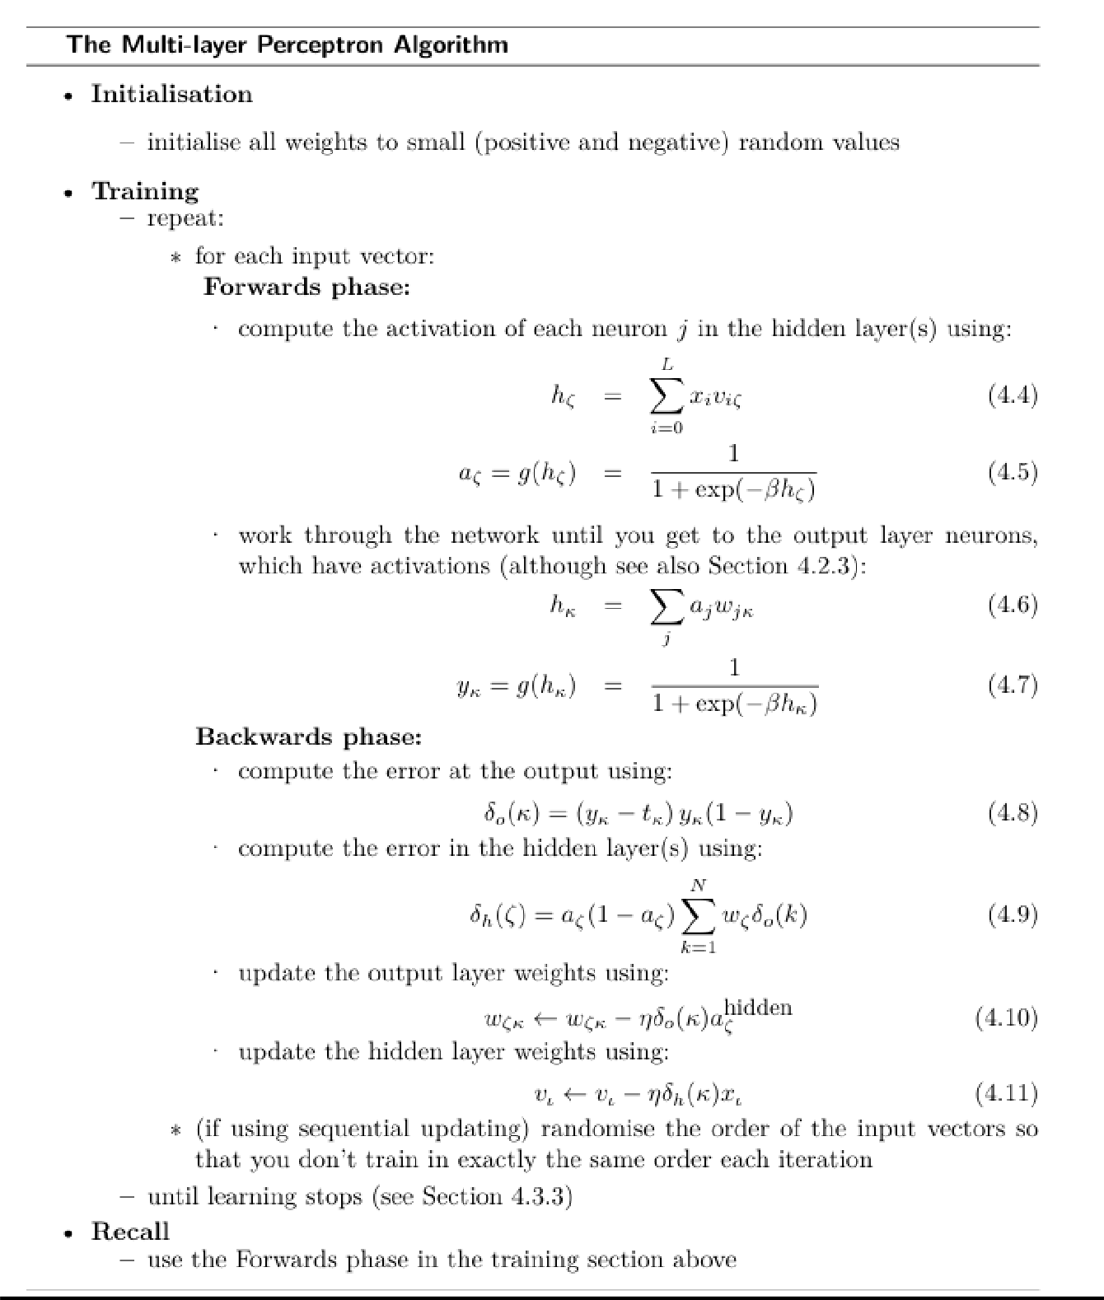

Initializing the Weights in an MLP
In an MLP, weights are initialized with small random positive and negative values so that neurons learn different features and training works properly.

Why Small Random Weights?
  - If all weights are set to zero, all neurons behave the same and learn the same features. This symmetry problem prevents the network from learning properly.
  - If weights are initialized to very large values, neurons may saturate (output close to 0 or 1), causing vanishing gradients and very slow learning.

If weights are initialized as small random values:
- The randomness prevents all neurons from behaving the same (breaks symmetry).
- This allows the network to learn complex patterns effectively.
- If some weights learn much faster than others, the network may favor certain inputs over others, leading to poor learning.

How to Choose the Initial Weight Values?
  - Each neuron receives inputs from multiple other neurons (either from the input layer or hidden layer).
  - A good way to set initial weights is to use the formula:
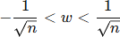

Where n is the number of neurons in the previous layer.

  - This ensures that the inputs to each neuron are well-balanced and do not become too large or too small.

Different Output Activation Functions
In an MLP, we often use sigmoid neurons in both hidden and output layers. This is good for classification problems because the output of a sigmoid is between 0 and 1, which can represent different classes.
Sometimes, we want the network to predict continuous values instead of just 0 or 1. This is called a regression problem. Sigmoid neurons are not good for this because they always give outputs between 0 and 1, which limits the range of predictions.

Solution: Use Different Activation Functions for the Output Layer

Linear Activation Function (for Regression Problems)
Instead of a sigmoid function, we use a simple function where the output is just the sum of the inputs:

This allows the network to produce any real number instead of just 0 or 1. The hidden layer remains the same, only the output layer changes.

Softmax Activation Function (for Multi-Class Classification)
Used when we have multiple output classes (for example, classifying an image as cat, dog, or bird).
It converts raw scores into probabilities by using the exponential function:
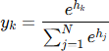

This ensures that the outputs sum to 1, making them valid probabilities.

Effect on Learning
  - Changing the activation function also changes how the network learns.
  - The learning rule (weight update equation) is modified accordingly.

For the linear function, the error is:

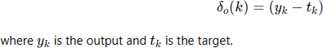
.

For the SoftMax function, the error update is:
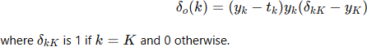
.

Alternative Error Function: Cross-Entropy
For classification problems, a special error function called cross-entropy can be used:
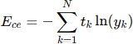

This error function improves learning when using Softmax activation.

When training a Multi-Layer Perceptron (MLP), there are two main ways to update the weights:

Sequential and Batch Training

Sequential Training(Online training)
Sequential training is a learning method in which the model updates its weights after each individual training example.

Sequential training is like learning step-by-step, where the model updates its knowledge immediately after each training example.

In Sequential Training, The network processes one input at a time. After each input, the error is calculated, and the weights are updated immediate.

Example of Sequential Training:

A spam email filter that updates its model every time a new email is received. After classifying each email as spam or not spam, the model immediately adjusts its weights based on the result.

Shuffling Data for Better Learning

In sequential training, the model learns from one sample at a time. If the data is always in the same order, learning can be slow. Shuffling the data each time makes learning faster

Advantages:
The following are the advantages of Sequential training

- Requires less memory as one sample is processed at a time.
- Adapts quickly to new or changing data.
- Suitable for real-time or streaming applications.
- Model starts improving immediately, without waiting for the full dataset.
- Works better in cases where the training data keeps changing over time

Batch Training (Default Method in MLP)
Batch training is a learning method in which the model updates its weights after processing the entire training dataset.

It is the default training method in Multi-Layer Perceptrons (MLP).

All training examples are passed through the network first.

  - The average error (difference between predicted and actual values) is calculated.
  - The weights are updated only once per epoch (one complete pass through all training data).

Advantages:
The following are the advantages of Batch training

- Batch training ensures the learning process is smoother and more reliable, gradually reaching the best solution.
- Gradient is calculated over the entire dataset, giving accurate updates.
- Less noisy weight updates compared to sequential training.
- Suitable for offline training where all data is available.

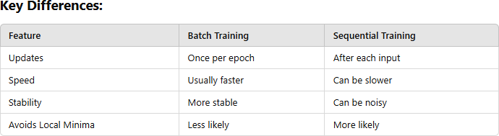

Local Minima
A local minimum is a point where the error is smaller than nearby points, but not the lowest error overall.
Gradient descent is used to reduce the error in a Multi-Layer Perceptron (MLP). It works by slowly adjusting the weights step by step in the direction that reduces the error, until the error becomes as small as possible.
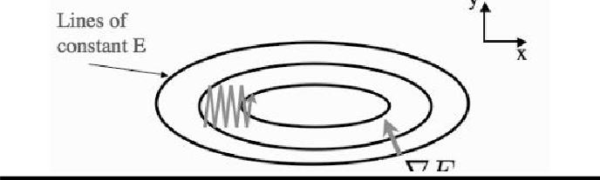

Imagine walking down a hill with your eyes closed, where you can only feel if you're moving higher or lower. Your goal is to find the lowest point, In the same way, gradient descent adjusts the network weights step by step to reach the lowest error.
However, the challenge is that the error landscape might have several local minima (smaller dips or valleys), which are lower points than the surrounding areas but not the absolute lowest (global minimum). If the network gets stuck in one of these local minima, it won't find the best solution.
The problem gets more complicated in higher dimensions (like when you have many weights and neurons). Sometimes the steepest direction might not lead you directly to the lowest point; it could take you sideways or cause the network to miss the best minimum.
To avoid getting stuck in a local minimum, one solution is to start training from different random initial points. This increases the chances of finding a better minimum. Another method is to add momentum to the training process. This helps the network keep moving in a consistent direction, even when it hits a small dip, preventing it from getting stuck and improving its chances of finding a better solution.
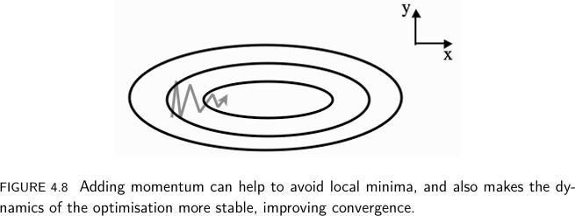

Picking Up Momentum
Momentum in Learning: Imagine a ball rolling down a hill. If the ball has momentum, it can roll over small bumps instead of getting stuck in small dips, and it can reach the lowest point more easily.
In a neural network, momentum works the same way. While updating the weights, we also use information from the previous updates. This helps the network avoid getting stuck at small errors and move faster and more smoothly toward a better solution (minimum error).

How Momentum Helps: Adding momentum makes learning more stable. It allows the network to use a smaller learning rate while still learning effectively. Instead of depending only on the current gradient, the network also uses the previous update to decide the direction. Because of this, learning becomes smoother and faster, helping the network reach a better solution.

Momentum Formula: To implement momentum, the weight updates in the network change. Instead of only using the current gradient (the change in error), we also use the previous update. The formula looks like this:
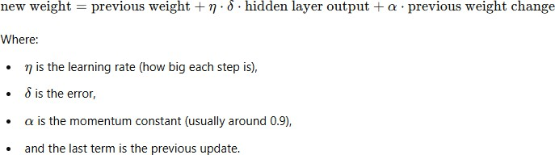

Weight Decay:

Weight decay gently reduces the network’s weights during training. Keeping weights small helps the network stay simple and focus only on important features, which can improve accuracy.
However, if the weights are reduced too much, the network may not learn properly. So, the amount of reduction must be chosen carefully, usually by testing different values.
Momentum helps the network learn faster and more smoothly, while weight decay keeps the network simple, prevents overfitting, and improves generalization.

Minibatches and Stochastic Gradient Descent
Minibatch and Stochastic Gradient Descent (SGD) are techniques used to improve the training process in neural networks. In the batch algorithm, the weights are updated after considering the entire dataset, which leads to more accurate updates but can get stuck in local minima. On the other hand, the sequential algorithm updates the weights after each input, but it might avoid local minima and find better solutions, though it takes longer.
Mini-batch gradient descent combines the advantages of both approaches. Instead of using the whole dataset (like in batch) or just one input (like in sequential), the dataset is divided into smaller batches. The network uses each batch to estimate the gradient (the direction in which weights should be updated), then updates the weights and moves on to the next batch.

This process is repeated for all batches, and the training set is shuffled to create new batches for the next iteration. Using mini-batches gives a slightly noisy (not exact) gradient, but this noise helps the network escape local minima and learns better.
Stochastic Gradient Descent (SGD) is an even more extreme version of mini batches. In SGD, the network uses just one random input vector at a time to estimate the gradient and update the weights. This can be very fast and useful when the dataset is large, as it avoids the high cost of using the entire dataset for each update.
Minibatch and stochastic gradient descent help speed up learning. Mini batches provide a good balance, while SGD is faster but less accurate for large datasets.

Multi-layer Perceptron in Practice
The design and implementation of the MLP network are necessary to address four distinct real-world problems, including regression, classification, time-series prediction, and data compression

Quantity of Training Data
The number of weights in an MLP containing one hidden layer can be calculated using the formula

(L +1) ×M +(M +1) ×N
in which L, M, and N represent the number of nodes for the input, hidden, and output Layers, respectively. The additional +1s are included to provide space for the bias nodes, which similarly contain variable weights. The back-propagation method modifies these weights based on the differences found in the training data. Increasing the amount of training data usually improves the learning process, but at the cost of more time consumption.

Number of Hidden Layers
When calculating the weights in an MLP, two important factors to consider are the number of hidden nodes and the number of hidden layers. These choices affect how well the algorithm works. According to the Universal Approximation Theorem, an MLP with just one hidden layer and enough nodes can learn any function. However, there is no exact formula for choosing the right number of hidden nodes, so experiments are needed to find the best setup.
The back-propagation algorithm can be used in networks with multiple layers, but updating the weights becomes very complex as more layers are added. In most cases, having just two layers—

one hidden layer and one output layer—is enough. This is because any continuous function can be approximated using a combination of sigmoid functions.
The figure illustrates how two hidden layers with sigmoid functions can be used to build ridge-like functions.

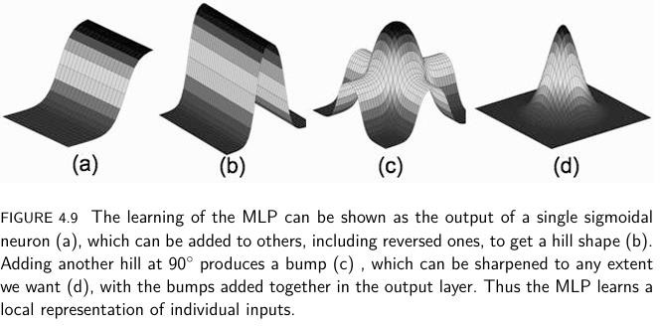

According to the Universal Approximation Theorem, a neural network with just one hidden layer can approximate any function, given enough hidden nodes. However, in theory, achieving perfect accuracy may require an infinite number of nodes, which is impractical.
By using two hidden layers, the network can effectively compute bump functions (small curved shapes) for different inputs. This ability allows the network to approximate complex continuous functions and define clear decision boundaries for classification tasks. With two
Hidden layers, the network becomes more powerful than a simple Perceptron, which cannot handle complex boundaries. (Decision boundaries are the lines that separate different classes in a classification problem).

When to Stop Learning
Training an MLP (Multilayer Perceptron) involves running the algorithm multiple times on the entire dataset and updating the weights based on the errors.
Deciding when to stop training is important to avoid two problems:

- Overfitting (learning the training data too well but failing on new data).
- Underfitting (not learning enough to make accurate predictions). There are simple stopping methods, but they have drawbacks:
  - Setting a fixed number of iterations (N): If we stop after a set number of steps, the network might stop too early, leading to poor learning. On the other hand, if we continue for too long, it might overfit the training data
  - Stopping when error is very small: If we wait until the error is tiny, the training might never stop, or the model might overfit, learning the training data too exactly and performing poorly on new data.
Using both methods together—setting a maximum number of iterations and stopping when the error is small—can be beneficial. Another good approach is to stop training when the error stops decreasing, as further training may not improve the model.
However, a better method is to use a validation set (a separate portion of data not used for training) to check if the model is generalizing well. This helps ensure that the model does not overfit the training data and remains effective for new inputs.
When you train a model using sum-of-squares error, the error decreases quickly at first. This is because the model is learning the basic patterns. After that, the error decreases more slowly as the model gets closer to the best solution (the local minimum).
The model will keep training until it reaches this point, but if it keeps training too long, it can start "memorizing" the training data instead of learning the general patterns. This is called overfitting, and it makes the model perform poorly on new data.
To avoid overfitting, we use a validation set. This is a separate set of data that the model hasn’t seen before. It helps us check how well the model is doing on new data. When the error on the validation set starts to increase, it means the model is starting to overfit. This is when we stop training, so the model doesn’t learn unnecessary details and can generalize better to new data.
The early stopping technique is a way to stop training a model at the right time to prevent it from learning too much and overfitting. Here's how it works:
- Train the model: You train the model for a set amount of time or until it has gone through a certain number of cycles.
- Check performance: After each cycle, you check how well the model performs on new data (called the validation set).

- Continue training: If the model keeps improving, you keep training it for a few more cycles.
- Stop when it starts to overfit: If the model starts doing worse on the validation set (even though it's still getting better on the training set), it means it’s starting to memorize the training data. This is called overfitting.
- Stop the training: When overfitting starts, you stop training to avoid this problem.
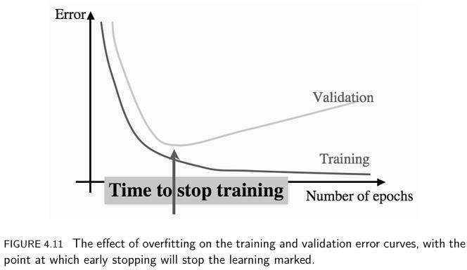

Examples of using the MLP

A Multi-Layer Perceptron (MLP) is commonly used for four main problems:

- Regression
- Classification
- Time-series prediction
- Data compression or denoising

A Regression Problem
Regression means predicting continuous values. In a regression problem, the goal is to find the mathematical function that was used to generate a given set of data points. These data points are often created using known formulas, such as sine and cosine waves, with some random noise added to make the data more realistic.

The main goal is to use the trained MLP to predict values for new inputs that were not in the training set.
The data can be generated using NumPy in the following manner:
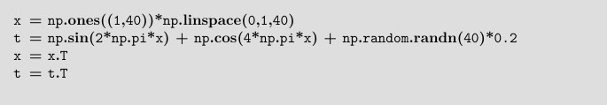
The reshape() method is needed because NumPy treats arrays with size N × 1 as lists by default. To understand this, observe the results of the np.shape() operation and how the transpose (.T) changes the array shape
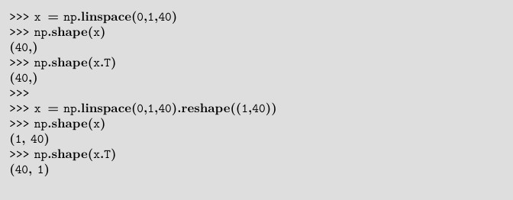
To visualize the data, create a plot, as depicted in the figure below, by using the following code

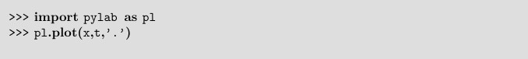
An MLP can be trained using the given input data. In this neural network, there is one input value (x) and one output value (t).
To get a continuous output value instead of just 0 or 1, linear neurons are used at the output layer. The best number of hidden neurons is not fixed, so it is usually found by experimentation to achieve the best performance.
Before training the MLP, the data is normalized by subtracting the mean and dividing by the variance. After normalization, the data is split into training, testing, and validation sets. Since there are only 40 samples, they are divided in the ratio 50% : 25% : 25%.
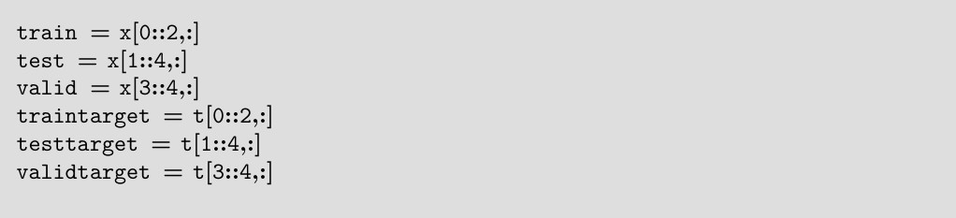
After preparing the data, the next step is to create and train the neural network. The network is built with three neurons in the hidden layer, trained for 101 iterations, and uses a learning rate of 0.25. These settings are chosen to test and verify that the model works correctly.
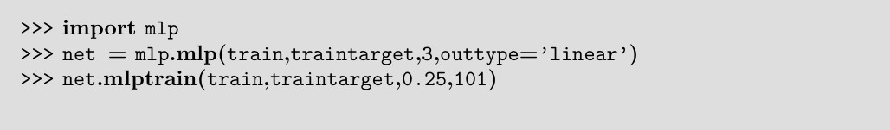
The output for the above-mentioned code snippet will be as follows:

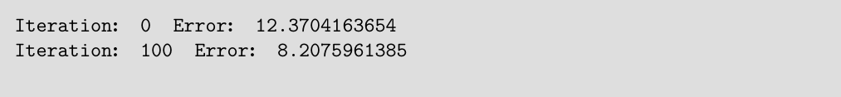
so, we can see that the network is learning, since the error is decreasing.
We now need to do two things: work out how many hidden nodes we need, and decide how long to train the network for.
In order to solve the first problem, we need to test out different networks and see which get lower errors, but to do that properly we need to know when to stop training. So we’ll solve the second problem first, which is to implement early stopping.
We train the network for a few iterations (let’s make it 10 for now), then evaluate the validation set error by running the network forward (i.e., the recall phase). Learning should stop when the validation set error starts to increase. We’ll write a Python program that does all the work for us.
The important point is that we keep track of the validation error and stop when it starts to increase.
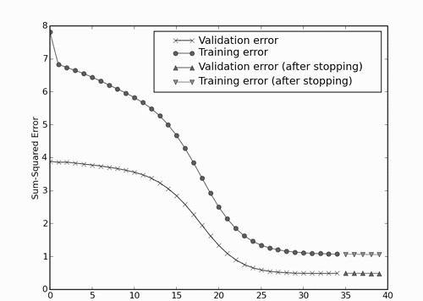

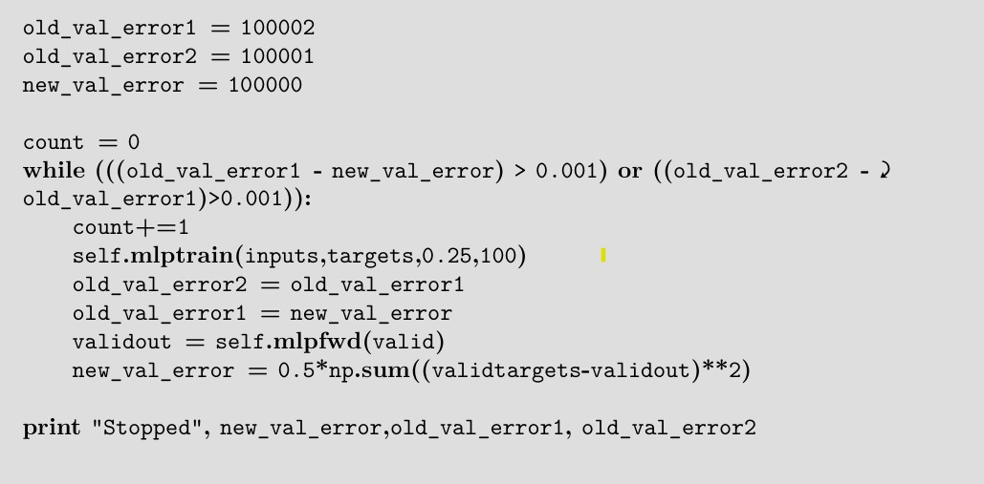
Finally, different network sizes are tested to find the best number of hidden nodes. Each network setup is trained multiple times to handle variations caused by random weight initialization. The average validation error is recorded, showing that networks with 2 to 10 hidden nodes perform better, and smaller networks often work more effectively.
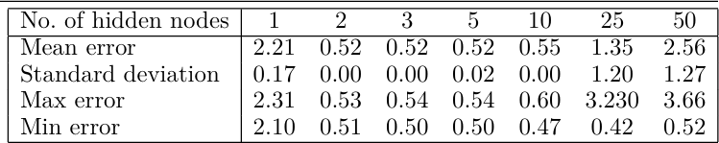

Classification with the MLP
There are two ways to handle the output in a classification problem
- Use a single output node and apply thresholds to decide the class.
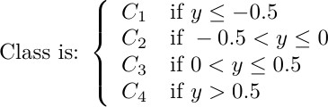
- The activation value of this node helps determine which category the input belongs to. For example, for a four-class problem, we could use:

The method shown in the above image assigns classes based on thresholds, but this has problems when there are many classes.

Problems with this approach:
- If a value falls near a boundary (e.g., y = 0.5), we guess its class, but the neural network doesn’t tell us how close it was to another class.
- This makes classification less reliable for values near the decision boundaries.

Better Approach:
- of-N Encoding (One-Hot Encoding)
Instead of using a single node with thresholds, we use multiple output nodes—one for each class. The correct class is represented with a 1, and all others are 0.

Example:
If there are 6 classes, the correct class is represented like this: (0,0,0,1,0,0) → The 4th class is correct.
This method is better because:
  - It removes the problem of boundary confusion.
  - It makes classification more accurate.
  - The output values are either 0 or 1 .

Hard-max activation function
The hard-max activation function is used mainly in classification problems. It converts the network’s output into a single clear class decision.
    - It assigns the value 1 to the neuron with the highest input
    - All other neurons are set to 0
This means the model chooses only one class, with no probability or confidence information.

Example:

Output values: [0.1, 0.3, 0.8, 0.2]

After hard-max: [0, 0, 1, 0]
The highest value is 0.8, so the network picks Class 3.

Disadvantage: This method gives clear decisions, but it does not show the model’s confidence. If two values are very close, we cannot tell whether the decision was easy or difficult.

Soft-Max Activation Function (Probability-Based)

The Softmax activation function is commonly used in multi-class classification problems. It converts the network’s output values into probabilities.

    - Each output value lies between 0 and 1

The sum of all outputs equals 1
    - The class with the highest probability is chosen

Example:
Output values before Soft-Max: [0.1, 0.3, 0.8, 0.2]

Output values after Soft-Max: [0.1, 0.2, 0.6, 0.1]

Class 3 has 60% probability, but Class 2 also has 20% probability, meaning the model is somewhat uncertain.

Softmax provides both a decision and confidence, unlike hard-max which gives only a yes/no output. That’s why softmax is widely used in neural network classification tasks.
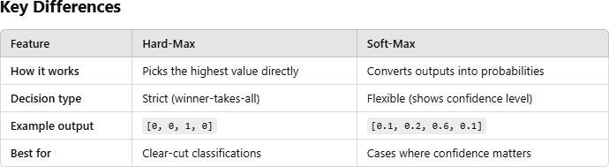

Conclusion

- Hard-Max is good for simple, unambiguous choices.

- Soft-Max is better when you need confidence scores and want to handle cases where multiple classes have similar scores.

A Classification Example: The Iris Dataset
The dataset classifies three types of iris flowers based on the length and width of their sepals and petals. It was originally analyzed by the famous statistician R.A. Fisher in the 1930s.
However, there is a problem:
The loadtxt() function in NumPy cannot read this dataset directly because the last column (which contains the flower species) is text instead of a number. ( the loadtxt() function in NumPy is designed to read numerical data from a text file.)
To solve this, there are two options:
- Manually edit the data in a text editor by replacing the text labels with numbers (e.g., "setosa" → 0, "versicolor" → 1, "virginica" → 2).
- Use Python code to handle the text column properly.
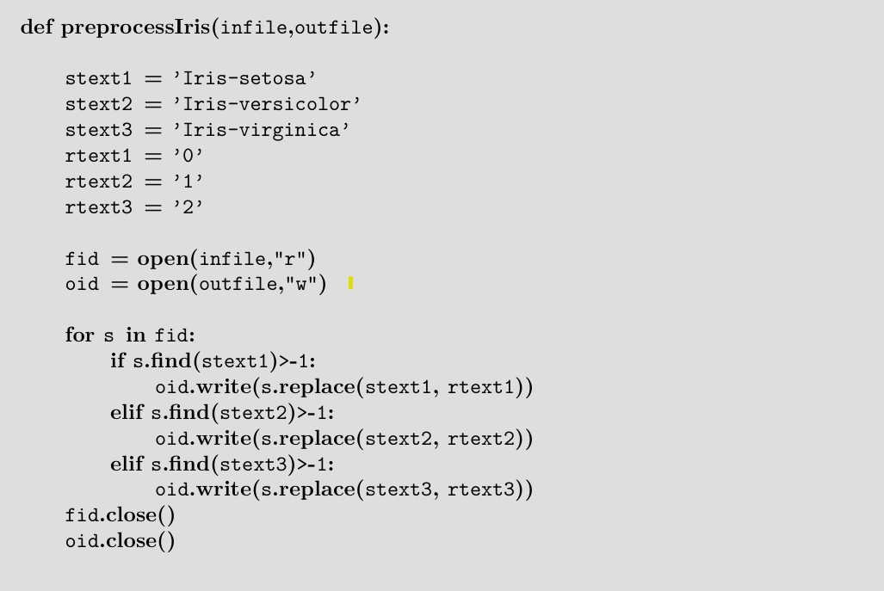

After converting the flower species names into numbers, you can load the data from the new file using loadtxt() in NumPy. In this dataset, the last column represents the class ID (0, 1, or 2), which indicates the flower type, while the first four columns contain the measurements for sepal length, sepal width, petal length, and petal width.
Before using the data for machine learning, the values are normalized so that all features are on a similar scale. Here, each value is divided by the maximum value in its column, while the class labels remain unchanged.
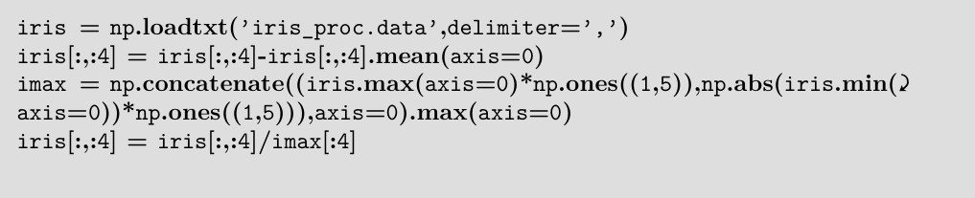
The first few data points will then look like:
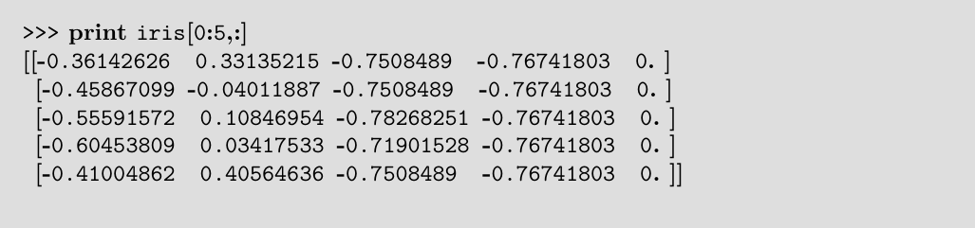
We need to convert the target values (class labels 0, 1, or 2) into 1-of-N encoding (one-hot encoding). This can be done by creating a new matrix filled with zeroes and setting the position corresponding to each class label to 1.
For example:
  - Class 0 → [1, 0, 0]
  - Class 1 → [0, 1, 0]
  - Class 2 → [0, 0, 1]

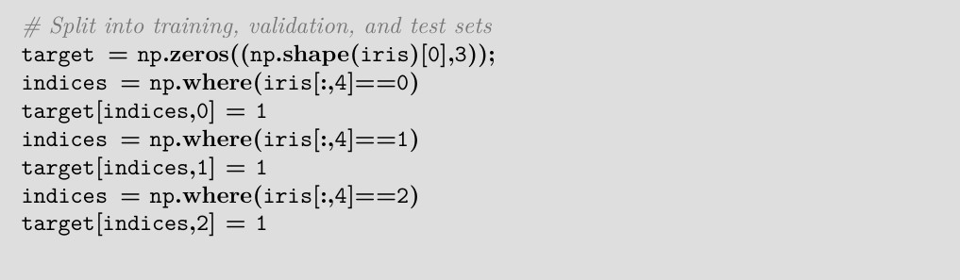
We need to split the dataset into training, testing, and validation sets.
The dataset contains 150 examples, evenly divided among the three classes (50 examples per class). Since all classes are of equal size, we don’t need to remove any data points.
We will split the data as follows:
    - 50% for training (75 examples)
    - 25% for testing (37 or 38 examples)
    - 25% for validation (37 or 38 examples)
Since the first 50 examples belong to class 1, the next 50 to class 2, and so on, we must shuffle (randomize) the data before splitting. This ensures that all sets contain a balanced mix of classes.
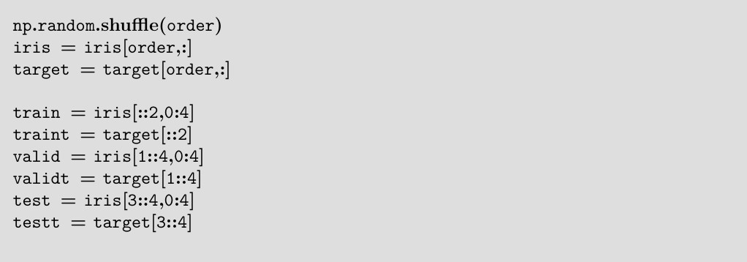

Now, we are finally ready to set up and train the network. The commands used for this should already be familiar from previous steps.

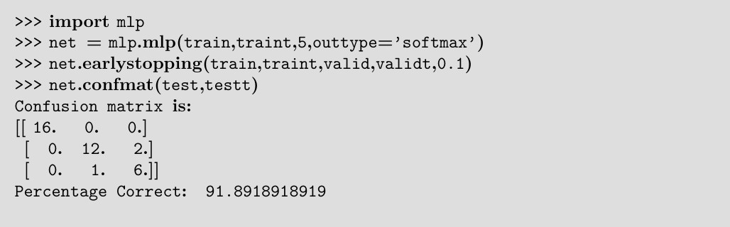
The algorithm correctly classified almost all the test data, making mistakes on only two examples from class 2 and one example from class 3.

Time-Series Prediction
Time-series prediction is the process of using past data points to make predictions about future values. It is difficult because patterns and trends can repeat in different ways over time. To make accurate predictions, we must choose how much past data to use and the time gap between data points. These choices are important for making good forecasts.
Time-series prediction is used in many real-world problems like:
    - Stock market prediction – guessing future prices of shares
    - Disease trend prediction – guessing how fast a disease might spread
But these predictions often fail because patterns in the data may look similar at different scales.

For example, if you look at average temperatures over time, you might notice that summers are usually hot and winters are cold — this is a seasonal pattern. But if you want to find out whether summers are getting hotter every year, it can be hard to tell. That’s because the hot summer days are far apart (once a year), so it's not easy to see a clear trend just by looking at the data.
We can use a neural network (f) to help decide how much data to use and how often to take it when predicting something like y.

Here, t and k are chosen based on the specific problem.

For an instance, consider the daily recordings of the ozone layer's thickness over Palmerston North, New Zealand, spanning from 1996 to 2004.

The collection consists of 2855 measurements, each including four elements. year, day of the year, ozone level, and Sulphur dioxide level.
Dobson units can determine the thickness of stone. The reduction of stratospheric ozone is almost responsible for the wonder of global warming and the increased incidence of skin cancer. New Zealand is very close to the big ozone hole over Antarctica.
The thickness of the ozone layer doesn’t stay the same all year — it changes naturally during different seasons.
The plot shown in the figure below demonstrated this clearly. A common time series problem involves forecasting future ozone levels and determining whether there is a noticeable drop in the average ozone level.
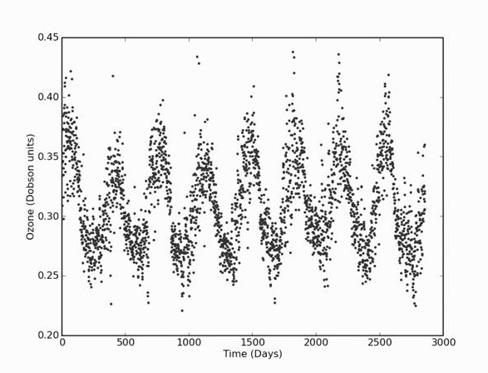

Data Compression: The Auto-Associative Network
An auto-associative network (autoencoder) is a type of multilayer Perceptron that is trained to reproduce the same input at its output.
At first, it may look like the network is simply copying the input to the output. However, there is an important difference:

    - In the middle of the network, there's a hidden layer with fewer neurons than the input. This part is called a bottleneck.
Because of this bottleneck, the network is forced to compress the input data into a smaller form. This compressed form captures the most important features of the data, not the exact copy.

Organization and Operation
Input Layer: This layer is responsible for receiving the input data.
Hidden Layer (Bottleneck): This layer has a reduced number of neurons compared to the input layer, which forces the network to minimize the data.
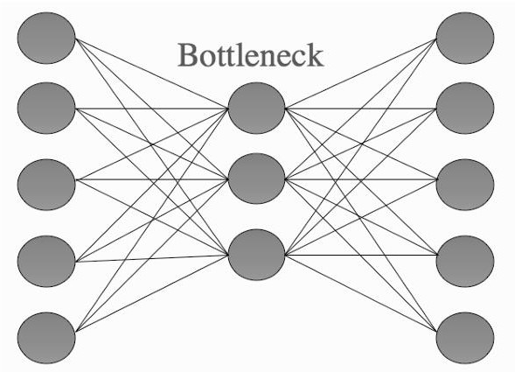
The auto-associative network. Output Layer: This layer is designed to replicate the input data.
The smaller dimensions of the hidden layer effectively capture the most crucial information, so efficiently eliminating any noise.
Application: Data Compression
An autoencoder can be used for data compression by reducing the dimensionality of data such as images. The network learns to compress the input data into a smaller representation in the hidden (bottleneck) layer by storing only the most important features, and later reconstructs the original data from this compressed form.

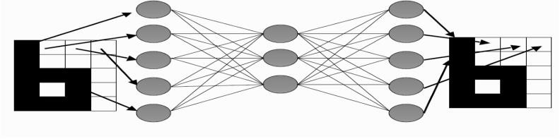
Schematic showing how images are fed into the auto-associative network for compression In a neural network, activations are the outputs of the neurons (nodes) in a layer after processing the input.
Each neuron:
- Takes input (like pixel values),
- Does some calculation (like multiplying by weights and adding bias),
- Applies an activation function (like ReLU or sigmoid),
- Then gives an output — this output is called the “activation.”

Procedure
  - Transform the image into a vector with a single dimension that contains the Intensity value.
  - Train the neural network to exactly replicate the image.
  - Save the hidden layers activations and the second layer's weights. Activations
  - Regenerate the image by passing the hidden activations across the second layer

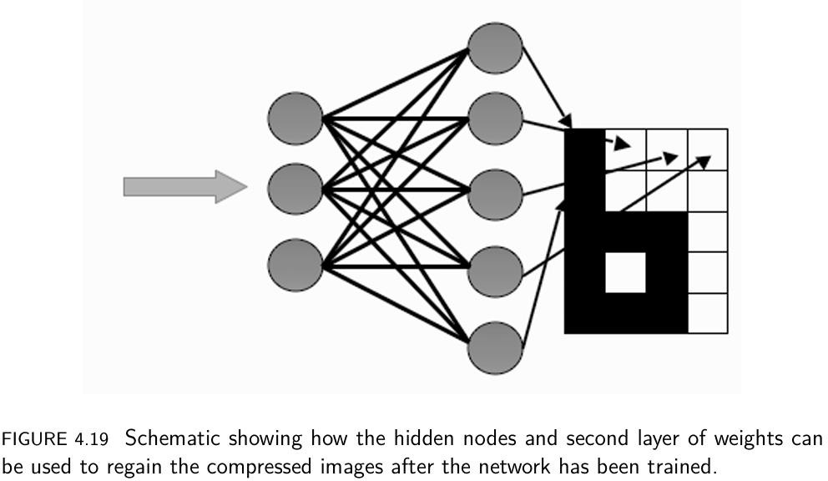

Denoising
Denoising is the process of eliminating noise or unwanted random variations from data, images. In images, it means removing grainy or blurry spots to improve the clarity and quality of the picture.

Procedure
- Train the network: Teach the neural network using clean, noise-free images.
- Add noise: Give the network an image that has been altered with noise.
- Clean the image: The network will remove the noise and produce a cleaner version of the image, improving its quality.

Representation of. Hidden Layers
When the neurons (hidden nodes) in the network use simple calculations (linear activations), the network learns the most important features of the image or data (called principal components). This helps the network understand the main patterns or structure of the input data.

Overview (List and explain the features of using MLP within a dataset)

Choosing Inputs and Outputs
Before using a Multi-Layer Perceptron (MLP) to solve a problem, it's important to manage both the input data and the expected output.
Here’s what you need to do:
- Choose the right parameters: Select the important features or variables for the task.
- Decide the output type: Choose how the network should produce its output, like using standard neurons or simple linear nodes.
- Use standard neurons for complex tasks like classification (non-linear outputs).
- Use linear nodes when you need continuous, real-valued outputs, like in regression problems.
These choices depend on the characteristics of the input data and the goals of the task.

Standardizing Inputs
Standardizing the input data means adjusting it so that all the features (variables) are on the same scale. Here's how it's done:
- Subtract the average: For each feature, subtract the average (mean) value of that feature from each data point.
- Divide by the standard deviation: Then, divide by the standard deviation of that feature. This makes sure the data is centered on zero and has a consistent spread.

Dividing the Data
Split the data into distinct training, testing, and validation sets in order to exactly analyze the network's performance. The standard ratio for allocating data into training, testing, and validation sets is 50:25:25, accordingly. If the available data is insufficient, apply cross-validation.

Adopting Network Architecture
Calculate the quantity of input and output nodes, and determine the necessity of a hidden layer. If that is the case, consider the number of neurons and the possibility of including other hidden layers. A network with greater complexity requires a larger amount of training data and time, and is more susceptible to overfitting. A common strategy involves conducting experiments with various architectures and subsequently adopting the model that exhibits greater efficiency.

Network Training
Use the MLP algorithm on the training data, usually with early stopping. Throughout the training process, it is advisable to periodically evaluate the network's generalization capability by testing it with the validation set. When the frequency of validation errors increases, it indicates the networks overfitting, prompting the halt of the training process.

Network Testing
After completing the training, apply the test data to determine the network's efficiency on unknown data. This final examination evaluates the probability of the network's optimal performance on fresh, real-life data.

DERIVING BACK-PROPAGATION
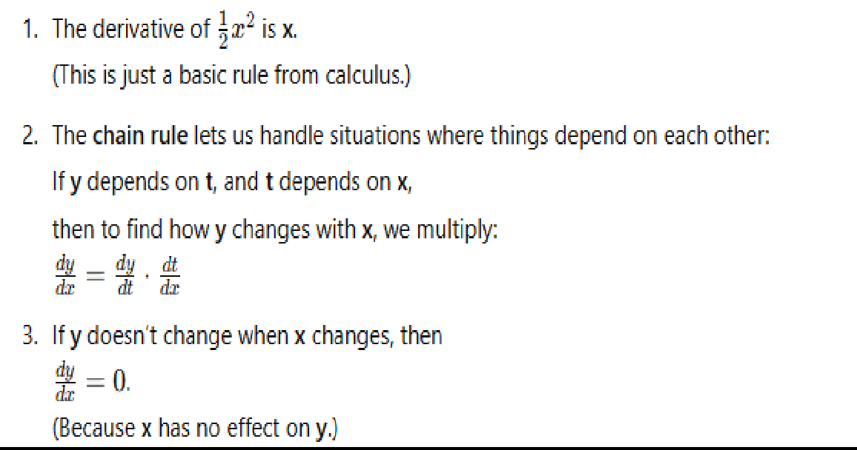
To understand backpropagation, we need to focus on only three key ideas

The Network Output and the Error
The output of a neural network at the end of the forward phase depends on three things:
- The current input (x)
- The activation function g(·) used by neurons
- The weights of the network (v for the first layer and w for the second)
The inputs and activation function remain fixed, so learning is done only by adjusting the weights. By adjusting the weights, we improve the network’s performance — this is how learning happens. But we do need to think carefully about which activation function we use. The old function we used in the Perceptron (called the threshold function) is not good for this because it’s not smooth because it jumps at 0, so we can’t take its derivative.
How we measure the error in the network. Here’s what has happened so far in the algorithm:
- We gave the inputs (x) to the network.
- The first set of weights (v) was used to calculate the hidden layer’s values (called activations).
- Then, those hidden values and a second set of weights (w) were used to calculate the outputs (y).
- These outputs are the final result from the network. A few notations:
- i: stands for input nodes
- j: stands for hidden layer neurons
- k: stands for output neurons

The Error of the Network
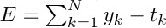
We want to reduce the error in our network. Before, we used an error function like
This error function measures the difference between the network’s output yk and the target value tk for each output node. We then use a rule to reduce this error.
This approach has a problem: if one output is too low and another is too high, the errors can cancel each other out, so the true total error is not measured correctly.
To fix this, we’ll use a sum-of-squares error function. This works by:
- Taking the difference between yk and tk for each output node,
- Squaring that difference (so negative and positive errors don’t cancel),
- Then adding all those squared differences together.

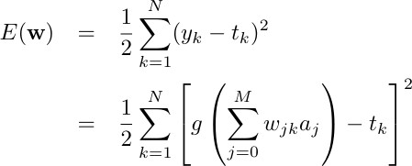

Now we see that yk is not just a simple value. It comes from the network’s calculation using weights and activations:
- aj: This is the activation from hidden neuron j
- wjk: This is the weight from hidden neuron j to output neuron k

- : This adds up all the inputs going into output neuron k, weighted by w
- g(⋅): This is the activation function (like sigmoid or ReLU) — it turns the total input into the final output value yk.

We are going to use a gradient descent algorithm that adjust search weight wik for fixed values of i and κ, moving in the direction that decreases the error E(w)

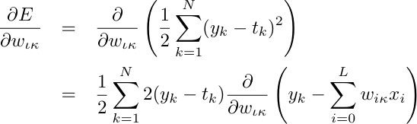

Requirements of an Activation Function
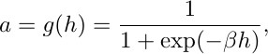
To model a neuron, we need a smooth activation function so the network can learn effectively. The function should produce a not activated output at one end and an activated output at the other, and change rapidly in the middle region. Sigmoid functions have this S-shaped behavior, so they are commonly used in neural networks.

Where β is a positive parameter

Back-Propagation of Error
The chain rule is used to find the derivative of a function that is inside another function.
If you have a function inside another function, like
f(g(x)) → "f of g of x"
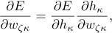
The change in error (E) with respect to a weight is found by splitting it into two smaller changes and multiplying them.
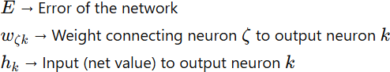
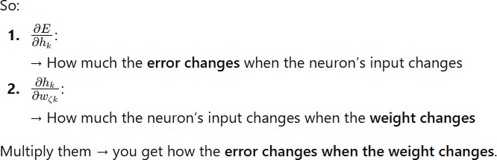

In a neural network:
- First layer → input → hidden layer

Second layer → hidden layer → output layer
So, second-layer weights are: The weights that connect the hidden layer neurons to the output neurons.
To understand how a second-layer weight affects the error, we break it into two steps: how the error changes with the neuron’s input, and how that input changes with the weight. This splitting is done using the chain rule.

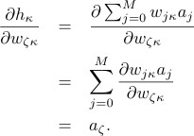
During training, we assign error to the correct neurons so their weights can be adjusted properly. This error is measured using the delta (δ) term.
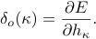

We can use the chain rule again:
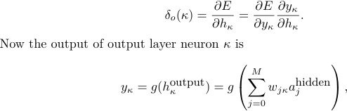

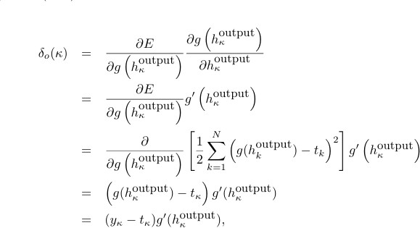

Radial Basis Functions and Splines – Concepts – RBF Network
In Machine learning data can be in the form of 2 types.
Data can be either linearly separable data (or) non- linearly separable data
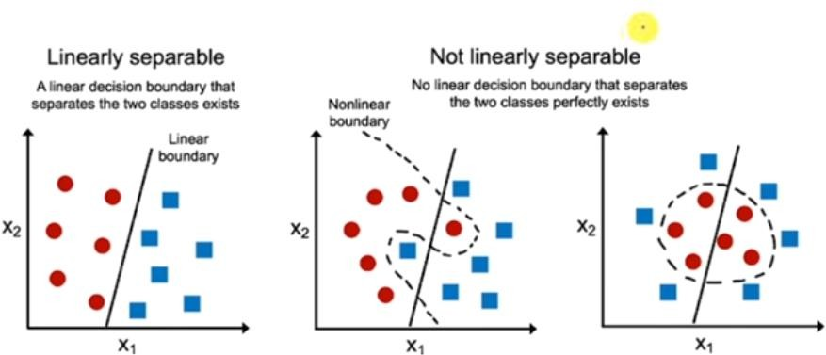

Single layer Perceptron can be used for classifying linearly separable data.
Multilayer Perceptron can be used for classifying non- linearly separable data.

Radial Basis Functions is a type of Multilayer Perceptron which has one input layer one output layer with strictly one hidden layer.
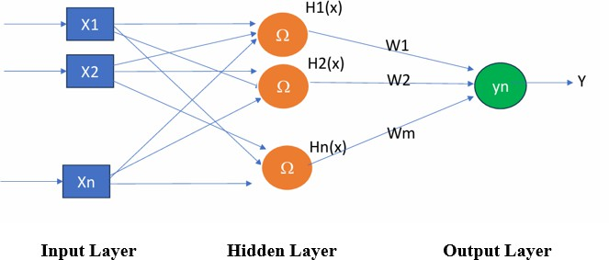

The hidden layer uses a special non-linear function called a radial basis function. This function changes the input into a higher-dimensional space, which helps the network to separate the data more easily.
Whenever we have non-linear data, we want to convert that non-linear data into linearly separable data. To do that, each neuron in the hidden layer uses a non-linear radial basis function as the activation function. This helps to convert the data into a higher-dimensional space, where it can be more easily separated.

For example, if you have 2- dimension data which is non-linearly separable we convert that 2-dimension data into 3-dimension data so that it will become linearly separable data. Once it is converted into linearly separable data it will be classified with the help of output layer neuron.
This can be used in
- Classification
- Interpolation
- Function approximation
- Time series prediction

- System control.

Types of Radial basis function
The following is the popular Radial basis function
The Gaussian Radial basis function which monotonically decrease with distance from the center
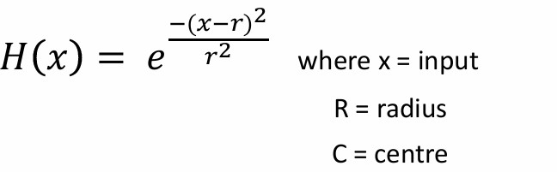

The following is another Radial basis function:
A multi quadratic RBF which monotonically increase with distance from the center
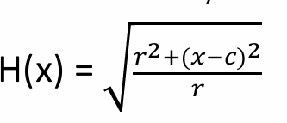
Where x=input
r=radius c=center

Algorithm for RBF
Input (or) input vector: x1, x2……. xn Output: yn
Assign random weights for every connection from the hidden layer to the output layer in the network in the range [-1 to +1]

Forward phase:
Step1:
In the input layer, the input and output are the same because the nodes directly pass the input values. Since no processing is done in the input layer.
Input at node i in the Input layer is Ii=xi
Where xi is the input received at node i,
Output at node i “Oi” in the input layer is Oi = Ii

Step2:
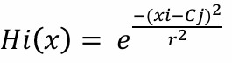
For each node j in the hidden layer, find the center (c) and the variance (r) Define hidden layer neurons with Gaussian RB whose output is

Step 3:

For each node k in the output layer, compute linear weighted sum of the output of each neuron k from the hidden layer neurons j
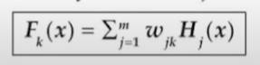
where Wjk = weight in the link from the hidden layer neuron j to the output layer k
Once you calculate the output at an output neuron, if the result is satisfactory, you can stop. The current weights on the edges from the hidden layer to that output neuron are considered final.
If you are happy with that particular output then we need to perform Backward Phase.

Backward phase:
- Train the hidden layer using Back Propagation
- Update the weights between the hidden layer and output layer
RBF Networks are conceptually similar to K-Nearest Neighbor (k-NN) models; however, their implementation is distinct. In RBF the main idea is that we can guess something’s value by looking at other things nearby that are similar.

Here’s how RBF Networks operate:
- Input Vector: The network receives an n-dimensional input vector that needs classification or regression.
- RBF Neurons: When the network gets a new input, it compares it to examples it learned during training. These examples are stored in the hidden neurons. The network measures distance to find which examples are closest to the new input.
- Activation Function: The Euclidean distance is transformed using a Radial Basis Function (typically a Gaussian function) to compute the neuron’s activation value. This value decreases exponentially as the distance increases.

- Output Nodes: Each output node calculates a score based on a weighted sum of the activation values from all RBF neurons. For classification, the category with the highest score is chosen.

Key Characteristics of RBFs
- Radial Basis Functions: These are real-valued functions dependent solely on the distance from a central point. The Gaussian function is the most commonly used type.
- Dimensionality: The network’s dimensions correspond to the number of predictor variables.
Predictor Variables: These are the features or independent variables in your dataset that are used to predict the target variable (output)
Network Dimensions: In a neural network, the input layer consists of nodes (neurons) that correspond to the features of your data. If you have, for example, 5 predictor variables (features), the input layer will have 5 nodes, one for each feature
- Center and Radius: Each RBF neuron has a center and a radius (spread). The radius affects how broadly each neuron influences the input space.

Architecture of RBF Networks
The architecture of an RBF Network typically consists of three layers:

Input Layer
Function: The input layer receives the input features and passes them directly to the hidden layer.
Components: The input layer has one neuron for each feature in the input data. Each feature is connected to its corresponding input neuron.

For example, if your input data has 3 features (like height, weight, and age), the input layer will have 3 neurons, with each neuron representing one of those features.

Hidden Layer
Function: The hidden layer applies Radial Basis Functions (RBFs) to perform a non-linear transformation of the input data.
Components: Each hidden neuron uses an RBF (usually Gaussian) to process the input. The neuron’s response depends on how close the input is to its center.

RBF Neurons: Every hidden neuron has a center (prototype vector) and a spread parameter (σ). The spread controls how far from the center the neuron will respond, which determines the neuron’s output.

Output Layer
Function: The output layer combines the hidden layer outputs using weighted sums to produce the final output of the network.
Components: Each output neuron adds up the hidden layer outputs linearly. During training, the weights are adjusted to reduce the difference between the predicted and actual target values.
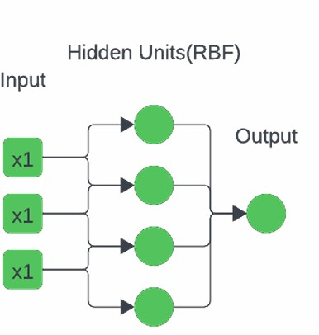

Training Process of radial basis function neural network
An RBF neural network must be trained in three stages:

Step 1: Selecting the Centers
Techniques for Center Selection: Centers can be chosen randomly from the training data or by using methods like k-means clustering.
K-Means Clustering: This technique divides the training data into k clusters, and the centers of these clusters are used as the centers for the RBF neurons..

Step 2: Determining the Spread Parameters
Function: The spread parameter (σ) controls each RBF neuron’s area of influence and determines the width of the radial basis function.
Calculation: σ can be set manually for each neuron or kept constant for all neurons. A common approach is to calculate it using the distance between centers—for example, dividing the largest distance between centers by the square root of twice the number of centers.

Step 3: Training the Output Weights
Linear Regression: Linear regression is used to find the output layer weights by reducing the difference (error) between the predicted output and the actual target values.
Pseudo-Inverse Method: A common way to calculate these weights is by using the pseudo-inverse of the hidden layer output matrix.
Universal Approximation: RBF Networks can represent any continuous function accurately if enough neurons are used.
Faster Learning: They usually train faster than other neural networks.
Simple Architecture: Their three-layer structure is easy to understand and implement.

Applications of RBF Networks
- Classification: RBF Networks are used for pattern recognition tasks like speech and image classification.
- Regression: They help predict values by modeling complex data relationships.
- Function Approximation: They are effective for approximating non-linear functions.

Curse of Dimensionality
The curse of dimensionality occurs when data has many features, making learning harder. It increases computation, causes overfitting, and may create misleading relationships. Using techniques like dimensionality reduction, feature selection, and proper model design helps reduce these problems and improves machine learning performance

The Curse of Dimensionality means that as the number of features increases, algorithm performance decreases. In high-dimensional data, points become sparse, so finding meaningful patterns becomes difficult.
As the number of dimensions increases:
- Your algorithm becomes slower and needs more resources.
- It may overfit (memorize noise instead of learning real patterns).
- It may find fake patterns that aren’t actually true.
- It becomes harder to train models that perform well on new data. To handle this, we use methods like:
  - Dimensionality Reduction (e.g., PCA),
  - Feature Selection (choosing only useful features),
  - Smarter model design (like using regularization).

How to Overcome the Curse of Dimensionality?
To overcome the curse of dimensionality, you can consider the following strategies:

Dimensionality Reduction Techniques:
Dimensionality reduction may be implemented in two ways.
- Feature selection
- Feature extraction
- Feature Selection: Feature selection means choosing only the most important features from the original dataset and removing the unnecessary or repeated ones. This reduces the number of features (dimensionality), making the model simpler, faster, and more efficient.
In feature selection, we are interested in finding k of the total of n features that give us the most information and we discard the other (n-k) dimensions.

- Feature Extraction: High-dimensional data is converted into a lower-dimensional form by creating new features that keep the important information. Methods like PCA and t-SNE are commonly used for this purpose
In feature extraction, we are interested in finding a new set of k features that are the combination of the original n features.

The best known and most widely used feature extraction methods are Principal Components Analysis (PCA) and Linear Discriminant Analysis (LDA).
In dimensionality reduction we need to measure error because we need to find whether a particular feature is important or not based on how much it is producing error.
If a particular feature is producing less error the meaning, is it is important, and we need to retain it.
If a particular feature is producing large error the meaning, is it is not important and we need to discard that feature.
There are 2 ways to measure error
In regression problems, we may use the
- Mean Squared Error (MSE) or the
- Root Mean Squared Error (RMSE)
MSE is the sum, over all the data points, of the square of the difference between the predicted and actual target variables, divided by the number of data points.
If Y1, Y2.... Yn are the observed values andŷ1, ŷ2 ŷnare the predicted values, then
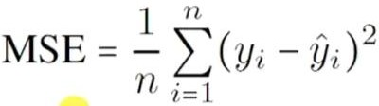
- RMSE is just the square root of MSE:

RMSE= √𝑀𝑆𝐸

In classification problems, we may use the misclassification rate as a measure of the error. This is defined as follows:

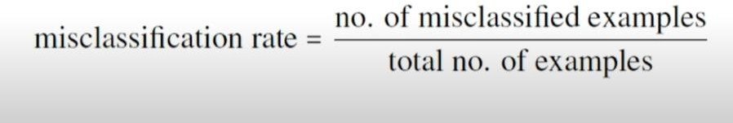
  - A lower rate means better accuracy.
  - A higher rate indicates the model is making more mistakes — possibly due to missing important features.
  - Lower misclassification = better accuracy.
  - If error increases after removing a feature → that feature is important

Data Preprocessing:
Data Preprocessing is the initial step in the machine learning pipeline where raw data is cleaned, transformed, and prepared for modeling. It ensures that the data is in a usable format for machine learning algorithms.

Normalization:
Scaling adjusts feature values to a similar range so that no single feature dominates others, especially in distance-based algorithms. It makes features more consistent and comparable.
Some machine learning algorithms (like KNN, SVM, and K-means) use distance (like Euclidean distance) to compare data points. If one feature (like salary) has large values (e.g., 50,000–1,00,000), and another feature (like age) has small values (e.g., 20–60), then salary will dominate the distance calculation.

Example:
Without normalization:
  - Salary: 80,000
  - Age: 30
→ Distance mostly depends on salary With normalization:
  - Salary: 0.8
  - Age: 0.3

→ Both features contribute fairly

Common Scaling Techniques:

- Min-Max Scaling: This scaling technique Scales data between 0 and 1
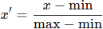

- Standardization (Z-score scaling): in this scaling technique Mean becomes 0, standard deviation becomes 1 and this technique is useful for algorithms like SVM, Logistic Regression

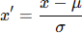

Handling Missing Values:
Missing data should be handled properly by either removing incomplete entries or filling in missing values (imputation) to make model training more reliable.

Why it's important:
Machine learning models can fail or give wrong results if missing data is not handled.

Ways to handle missing values:
- Imputation – Fill in the missing values using:
  - Mean or median (for numbers)
  - Most frequent value (for categories)
- Deletion – Remove the row or column if too many values are missing (but this may lose useful data).

Example:

Age | Salary
25 | 50000
30 | NA
28 | 55000

Here you can replace "NA" with average salary or drop the row.

Feature Selection and Dimensionality Reduction

- Feature Selection: SelectKBest selects the top k most important features using a chosen scoring function (such as f_classif). It keeps the features that are most strongly related to the target variable.
- Dimensionality Reduction: PCA reduces the number of features by converting them into fewer components that keep most of the important information..

Training the classifiers
- Training before Dimensionality Reduction: Train a Random Forest classifier (clf_before) on the original scaled features (X_train_scaled) without dimensionality reduction.
- Evaluation before Dimensionality Reduction: Make predictions (y_pred_before) on the test set (X_test_scaled) using the classifier trained before dimensionality reduction, and calculate the accuracy (accuracy_before) of the model.
- Training After Dimensionality Reduction: Train a new Random Forest classifier (clf_after) on the reduced feature set (X_train_pca) after dimensionality reduction.
- Evaluation After Dimensionality Reduction: Make predictions (y_pred_after) on the test set (X_test_pca) using the classifier trained after dimensionality reduction, and calculate the accuracy (accuracy_after) of the model

Interpolation in Machine Learning

Interpolation and extrapolation are used to predict values for data points we don’t have.
The method of guessing unknown values based on available data points is known as interpolation.
Interpolation means predicts within the range of known data.
Extrapolation means predicts outside the range of known data.
In regression and classification, machine learning predicts outcomes from input features. It can make accurate guesses for unknown values by interpolating between known data points.
Example
Consider the following dataset

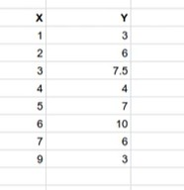

Here X-axis values are listed in first column and Y-axis values are listed in second column.
- axis values are listed as linear values (1-9) but Y-axis values can be any value but there must be some relation between X and Y but we can’t get any equation
For very value at x there is some value at y. Example if x=1 then y=3, if x=3 then y=6…. etc.
Predict y value at x=2.5 which is not there in the given dataset
Whenever you have data missing in your dataset and you want to interpolate that data based on whatever the data you have available.

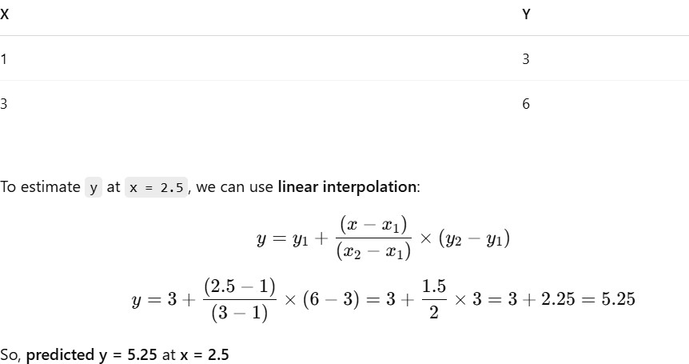

Interpolation Types
Interpolation methods vary depending on the type of data. Common types of interpolation include:
  - Interpolation in Linear Form: Linear interpolation estimates values between two points by drawing a straight line connecting them and finding values along that line.
  - Equation-Based Interpolation: Polynomial interpolation fits a curved (polynomial) function through the data points, allowing it to capture nonlinear relationships for a more flexible estimate
  - Interpolation of Splines: Spline interpolation uses piecewise polynomial functions to smoothly connect data points, avoiding sudden jumps in the estimates.
  - Interpolation of Radial Basis Function: RBF (Radial Basis Function) interpolation estimates values based on the distances between data points.

Interpolation in Linear Form
Linear interpolation estimates values between two points by drawing a straight line connecting them and finding values along that line.

Implementation

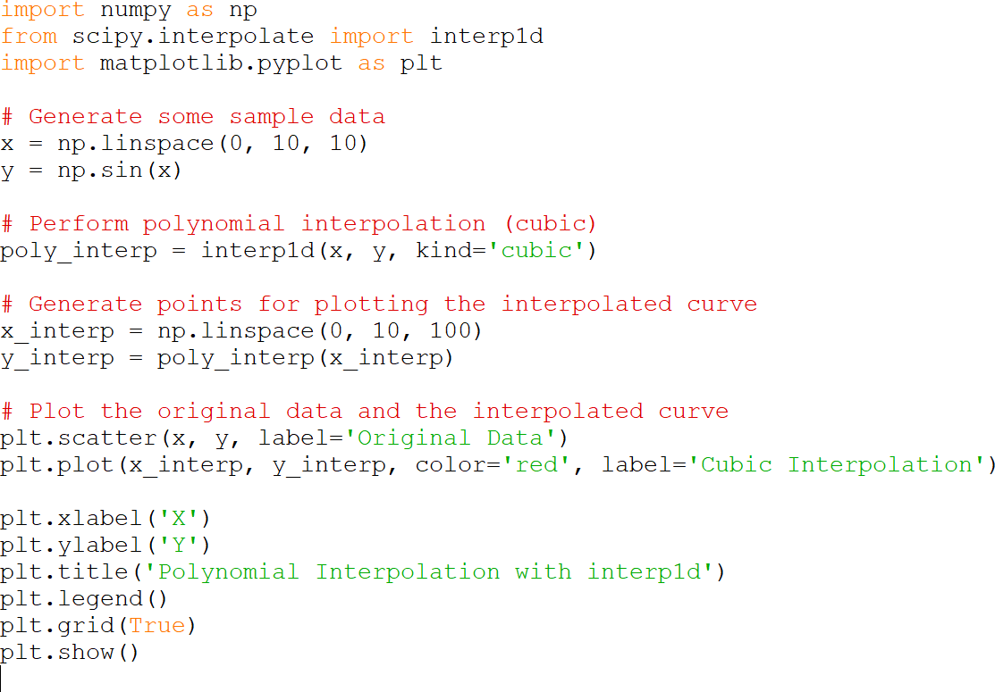

- This code snippet illustrates linear interpolation using LinearNDInterpolator from SciPy.
- It randomly generates 10 data points in 2D space with corresponding values.
- The LinearNDInterpolator function constructs an interpolation function based on these points. It then interpolates the value at a specified point and visualizes both the data points and the interpolated point on a scatter plot.
- Finally, the interpolated value at the specified point is printed

Polynomial Interpolation
Polynomial interpolation fits a curved (polynomial) function through the data points, allowing it to capture nonlinear relationships for a more flexible estimate.
This method helps approximate functions that are hard to write as simple formulas. For polynomial interpolation, common approaches include:

Lagrange polynomial 2. Newton’s divided differences

These methods are used to construct the interpolating polynomial for implementation.
In this method first, sample points are taken from a sine curve. Then, the interp1d function with
cubic spline is used to estimate values between these points.
Finally, the original points and the interpolated curve are plotted using matplotlib to show how well the interpolation estimates the function from limited data.

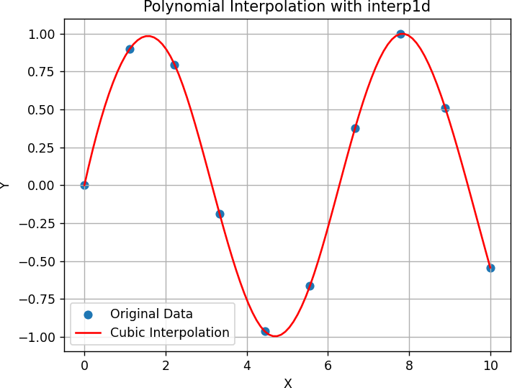

Applications Of Interpolation in Machine Learning
The method of guessing unknown values based on available data points is known as interpolation.
- Image Processing: Interpolation is used to resize images by estimating the values of pixels in the resized image based on the values of neighboring pixels in the original image.

- Computer Graphics: In computer graphics, interpolation is used to generate smooth curves and surfaces, such as Bezier curves and surfaces, which are used to create shapes and animations.
- Numerical Analysis: Interpolation is used in numerical analysis to approximate the value of a function between two known data points. This is useful in areas such as finite element analysis and computational fluid dynamics.
- Signal Processing: In signal processing, interpolation is used to increase the number of samples in a signal without changing its frequency.
- Mathematical Modeling: Interpolation is used in mathematical modeling to estimate unknown values based on known data points, such as in the construction of mathematical models for physical systems.
- Geographic Information Systems (GIS): Interpolation is used in GIS to estimate values of geographical features, such as temperature.
- Audio Processing: In audio processing, interpolation is used to resample audio signals

Support Vector Machines
Support Vector Machine (SVM) is a popular supervised learning algorithm used for both classification and regression tasks.
However, primarily, it is used for Classification problems in Machine Learning.
The goal of the SVM algorithm is to create the best line or decision boundary that can segregate n-dimensional space into classes so that we can easily put the new data point in the correct category in the future. This best decision boundary is called a hyper plane.
There can be multiple lines/decision boundaries to segregate the classes in n-dimensional space, but we need to find out the best decision boundary that helps to classify the data points. This best boundary is known as the hyper plane of SVM.

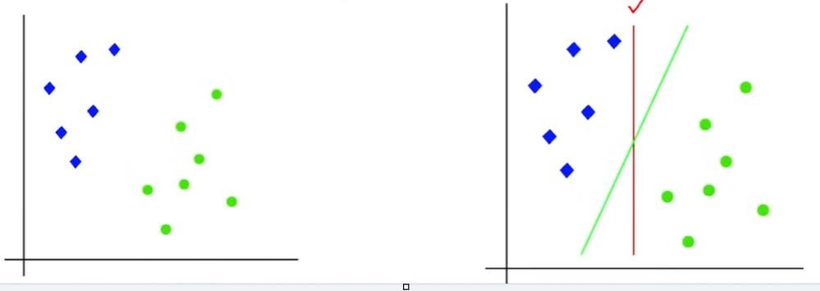
The dimensions of the hyper-plane depend on the features present in the dataset, which means if there are 2 features (as shown in image), then hyper-plane will be a straight line.
And if there are 3 features, then hyper-plane will be a 2-dimension plane.
We always create a hyper-plane that has a maximum margin, which means the maximum distance between the data points.
The data points or vectors that are the closest to the hyper-plane and which affect the position of the hyper plane are termed as Support Vector.
SVM can be of two types:
- Linear SVM: Linear SVM is used for linearly separable data, which means if a dataset can be classified into two classes by using a single straight line, then such data is termed as linearly separable data, and classifier is used called as Linear SVM classifier.
- Non-linear SVM: Non-Linear SVM is used for non-linearly separated data, which means if a dataset cannot be classified by using a straight line, then such data is termed as non-linear data and classifier used is called as Non-linear SVM classifier.

Example of Linear SVM:
The working of the SVM algorithm can be understood by using an example.
Suppose we have a dataset that has two tags (green and blue), and the dataset has two features x1 and x2.
We want a classifier that can classify the pair(x1, x2) of coordinates in either green or blue.

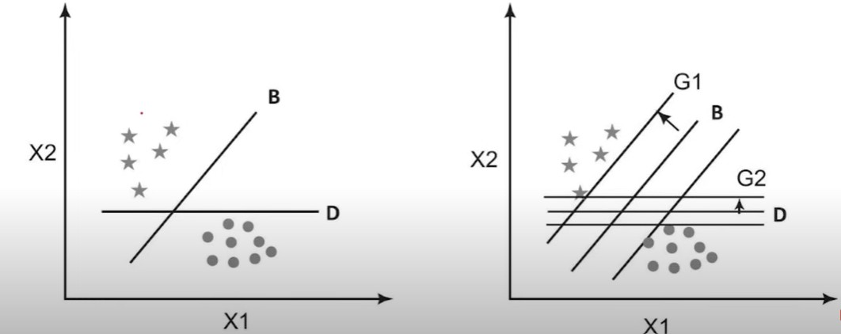

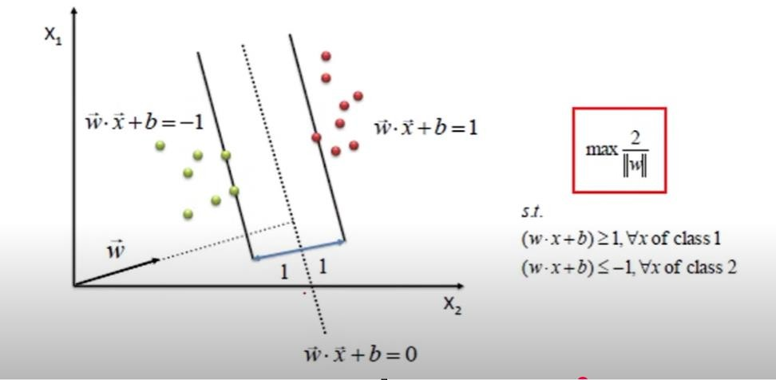

Non-Linear SVM:
If data is linearly arranged, then we can separate it by using a straight line, but for non-linear data, we cannot draw a single straight line.
So to separate these data points, we need to add one more dimension. For linear data, we have used two dimensions x and y, so for non-linear data, we will add a third dimension z.
It can be calculated as: z=x²+y²

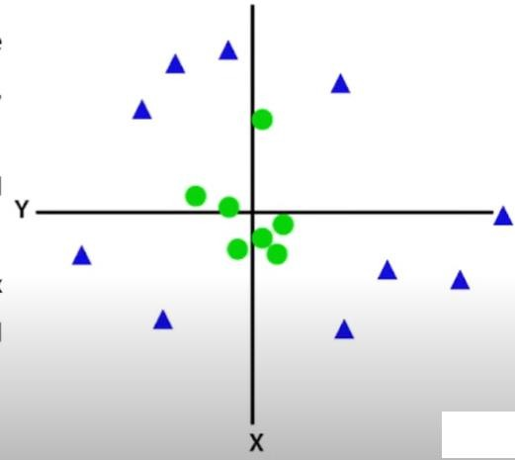

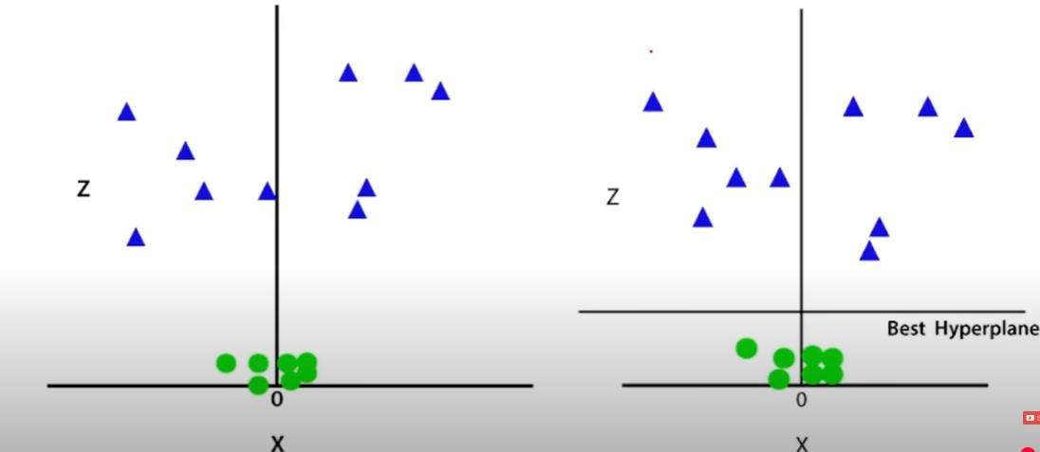

Advantages of Support Vector Machine (SVM)
- High-Dimensional Performance SVM works well with high-dimensional data, so it is suitable for tasks like image classification and gene expression analysis.
- Nonlinear Capability: By using kernel functions such as RBF and polynomial, SVM can effectively handle nonlinear relationships.
- Outlier Resilience: The soft margin in SVM allows it to ignore outliers, making it more robust for tasks like spam detection and anomaly detection.
- Binary and Multiclass Support: SVM works well for both binary and multiclass classification.
- Memory Efficiency: SVM uses only support vectors, which makes it more memory-efficient than many other algorithms.

Disadvantages of Support Vector Machine (SVM)
- Slow Training: SVM can be slow on large datasets, which may affect its performance in data mining tasks.
- Parameter Tuning Difficulty: Choosing the right kernel and tuning parameters like C requires care, which affects SVM performance.
- Noise Sensitivity: SVM performs poorly with noisy data and overlapping classes, which reduces its effectiveness in real-world applications.
- Limited Interpretability: In high-dimensional spaces, the SVM decision boundary becomes complex, making the model harder to interpret than others.
- Feature Scaling Sensitivity: SVM needs proper feature scaling; otherwise, its performance may degrade.

